PROJECT DOCUMENTATION

Azure 2-Tier Architecture with Public & Private Load Balancer

STUDENT: AMBATI MOKESH REDDY
BATCH : 31

Project Overview
This project demonstrates the implementation of a 2-tier architecture in Microsoft Azure, where:
- Web Tier uses NGINX
- Application Tier uses Apache Tomcat
- Communication is handled using Public and Private Load Balancers

Step 1: Resource Creation
First, I created the required resources in Azure:
- Created a Resource Group
- Created a Virtual Machine (VM) for Web Server
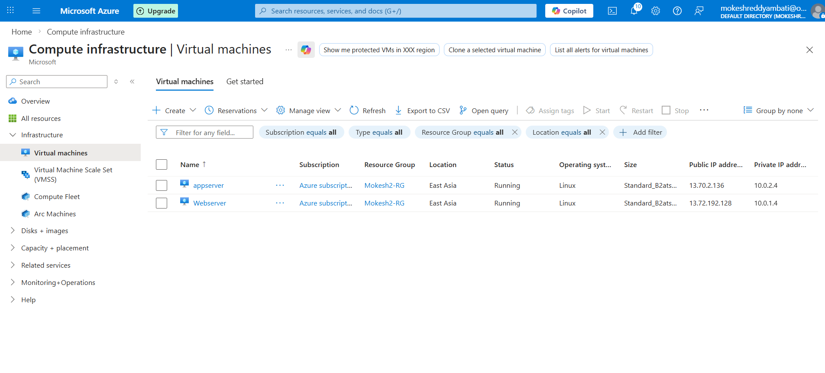
Step 2: Networking Configuration
While creating the VM, I configured networking:
- Created a Virtual Network (VNet)
- Created two subnets:
  - Web Subnet → for Web Server
  - App Subnet → for Application Server
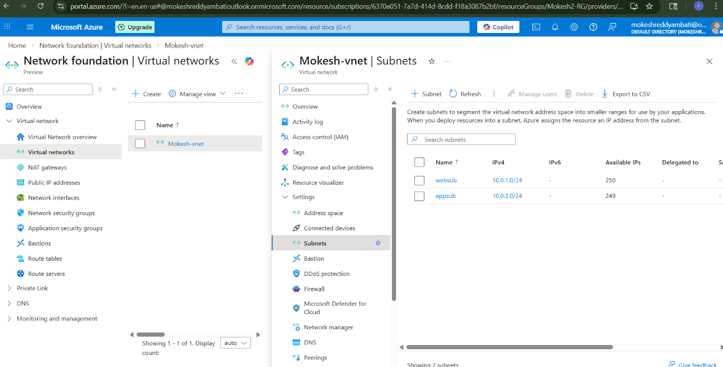
Step 3: Web Server Setup (NGINX)
In the Web Server VM, I installed NGINX using the following commands:
#!/bin/bash
sudo su
apt update
apt install nginx -y
This sets up the Web Tier to serve HTTP traffic.
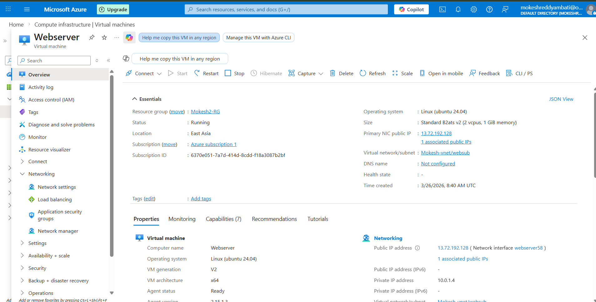

Step 4: Application Server Setup
- Created another VM for Application Server
- This VM is placed in the App Subnet
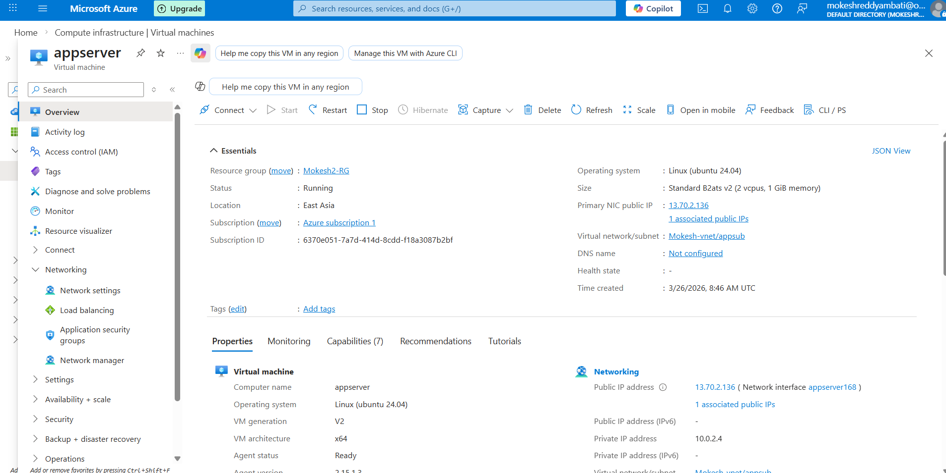

Step 5: NSG (Network Security Group) Configuration
Configured security rules:
Web Server NSG:
- Allow Port 80 (HTTP)
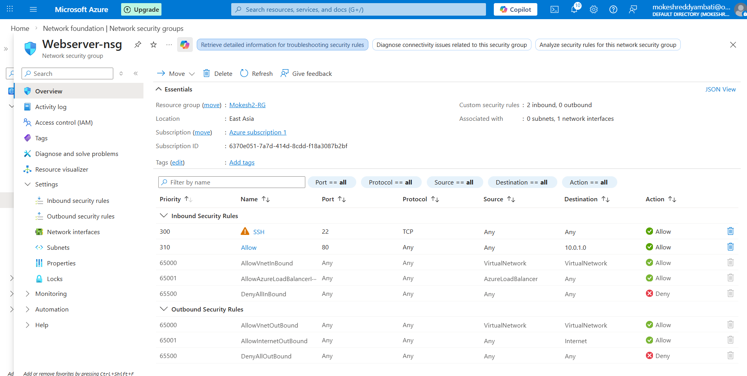
App Server NSG:
- Allow Port 8080 (Tomcat)
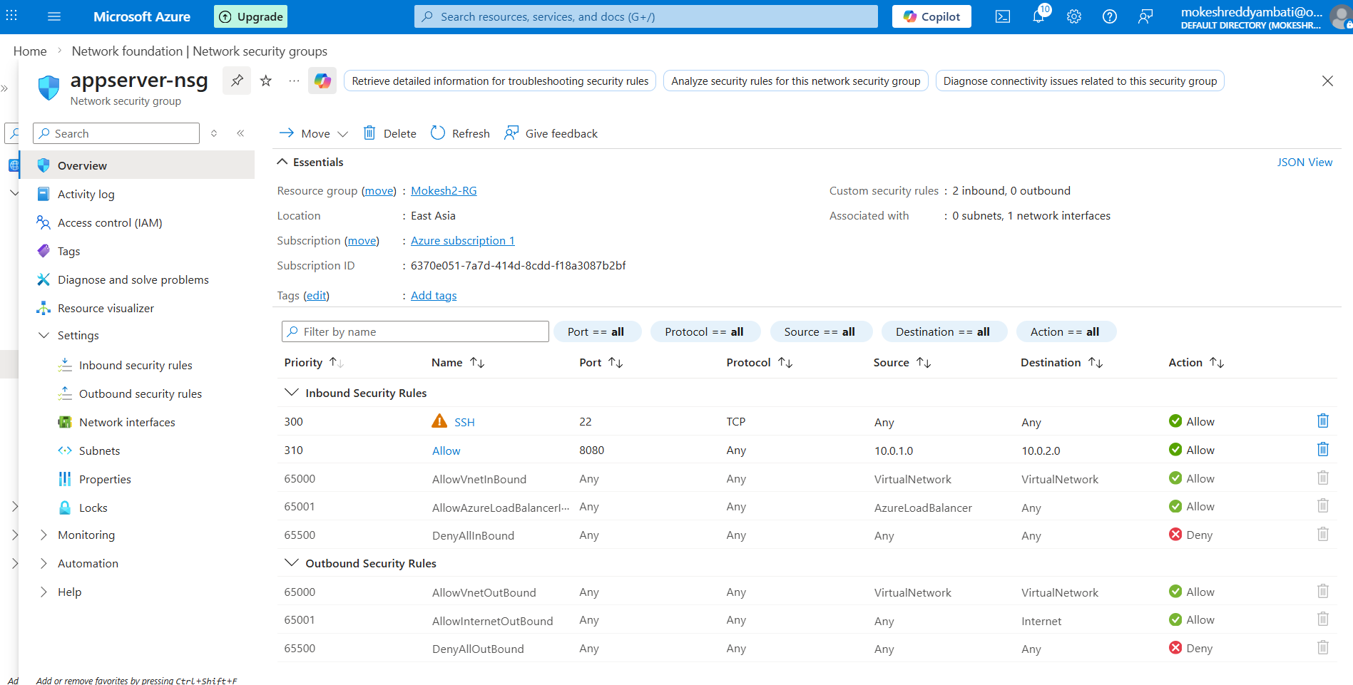

Step 6: Initial Testing
- Accessed the Web Server using its Public IP
- Verified that the NGINX web page is running successfully
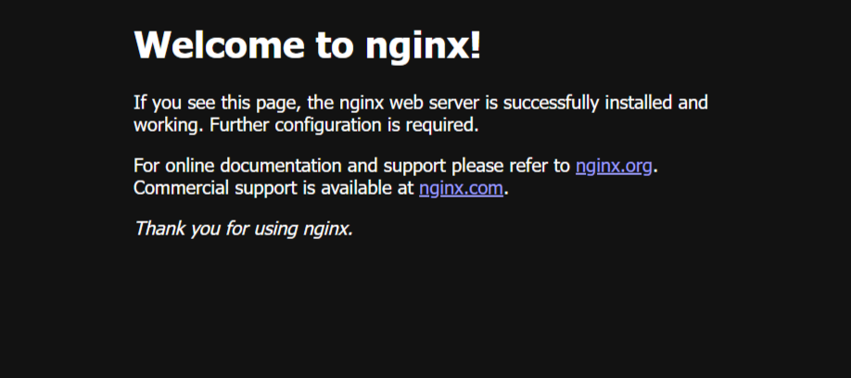

Step 7: Public Load Balancer (Web Tier)
Created a Public Load Balancer for the Web Server with:
- Frontend IP (Public)
- Backend Pool (Web VM)
- Health Probe (Port 80)
- Load Balancing Rule (HTTP – Port 80)
This distributes incoming traffic across web servers.
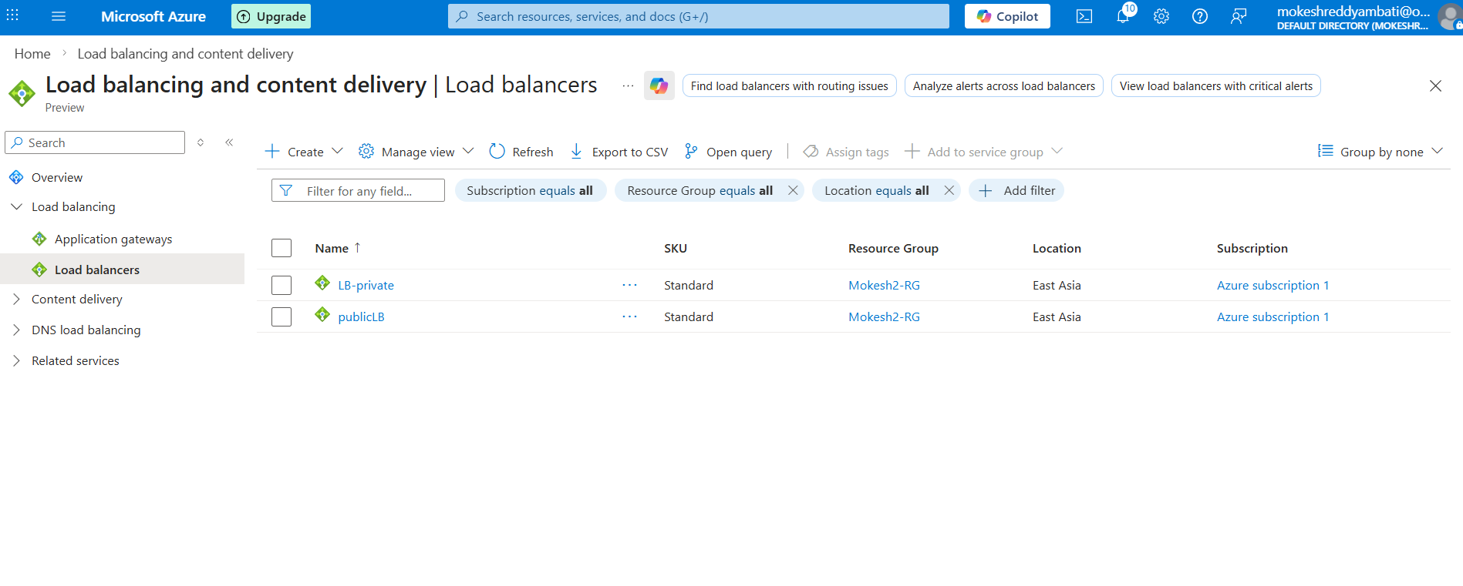
Step 8: Private Load Balancer (App Tier)
Created an Internal (Private) Load Balancer for the App Server:
- Frontend IP configured using App Subnet
- Backend Pool (App VM)
- Health Probe (Port 8080)
- Load Balancing Rule (Port 8080)
This ensures secure internal communication.
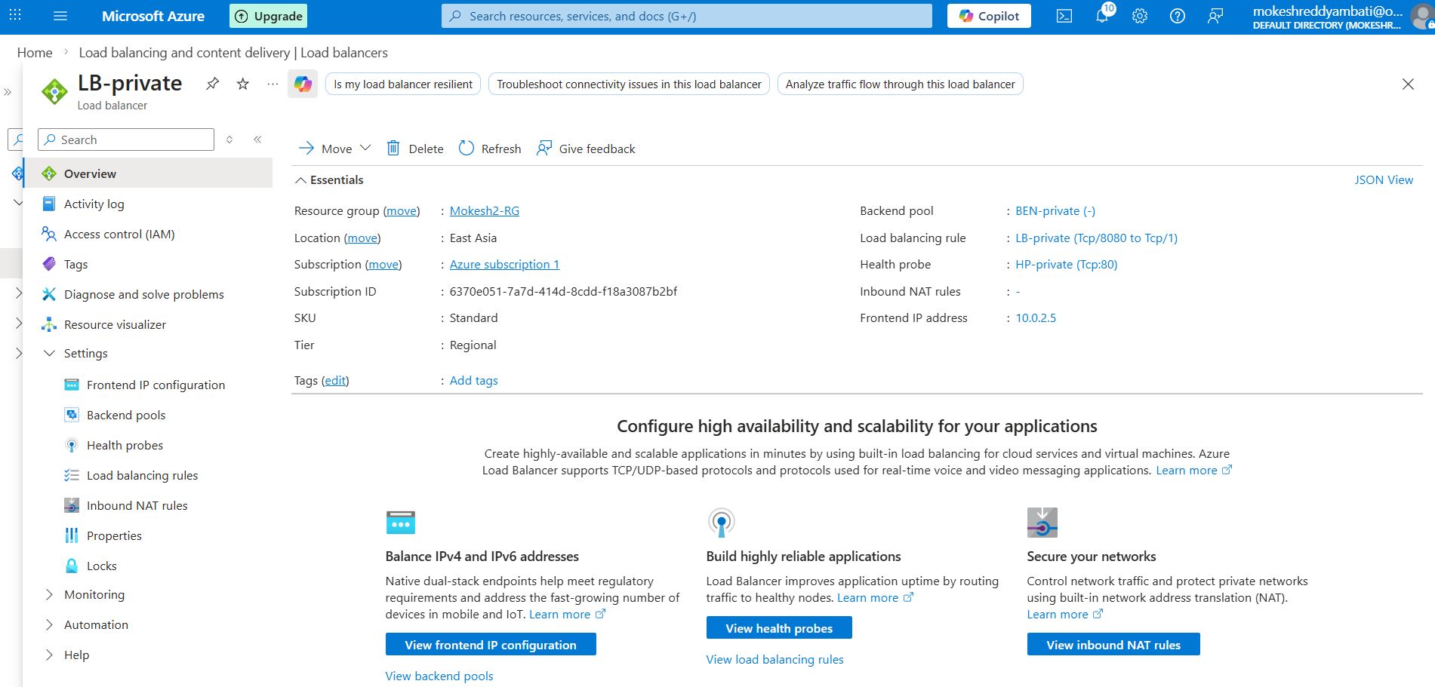
Step 9: Tomcat Installation (App Server)
Connected to App Server using MobaXterm and installed Tomcat:
sudo su
apt update
apt install default-jdk -y
apt install tomcat10

Step 10: Connectivity Testing
Tested communication between Web and App tier using:
telnet 10.0.2.4 8080
✅ Successfully connected, confirming:
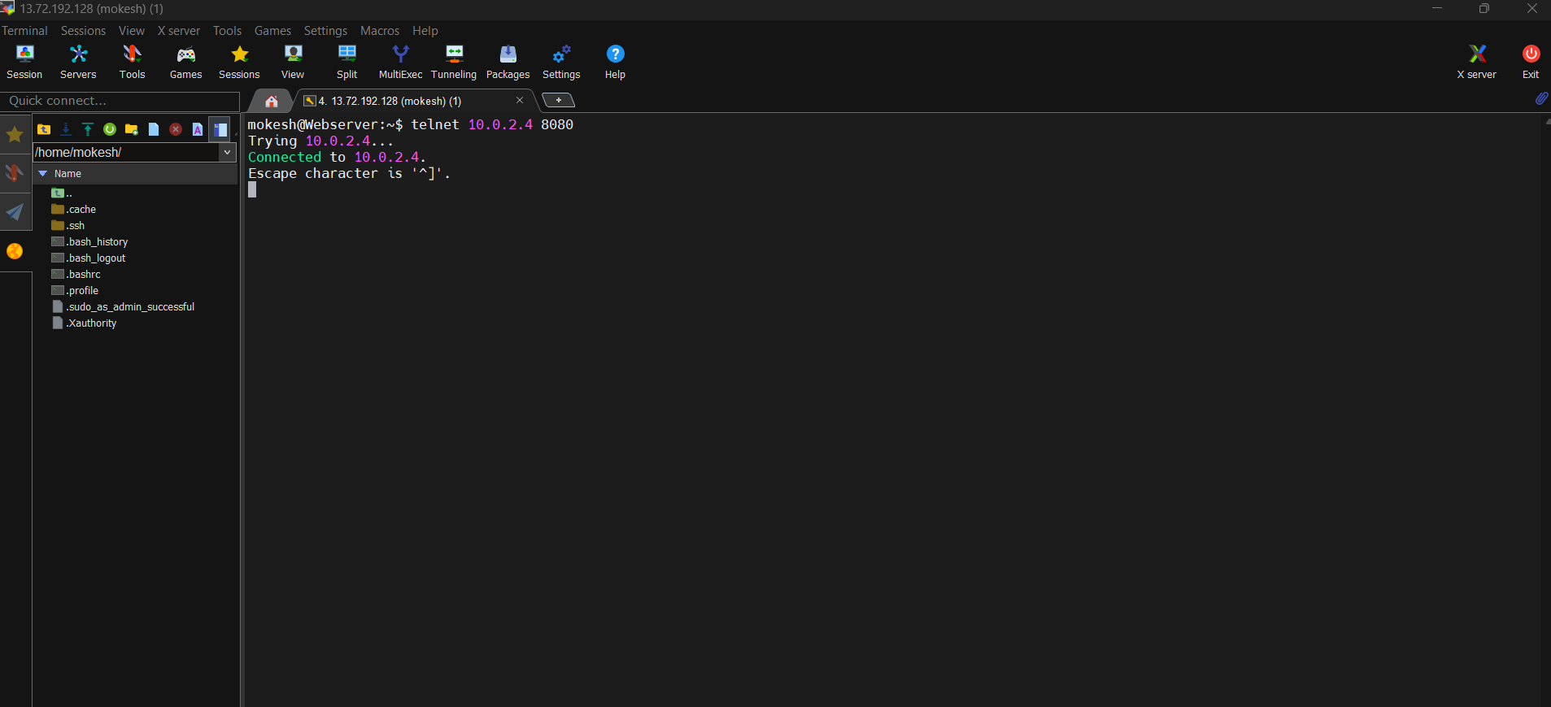

- Web Tier → App Tier communication is working

Conclusion
This project successfully demonstrates:
- Deployment of a 2-tier architecture in Azure
- Use of Public Load Balancer for external traffic
- Use of Private Load Balancer for internal communication
- Secure and scalable design using NSG rules and subnet isolation

